**Essay / Assignment Title: Computer Vision and Artificial Intelligence in Healthcare Image Bracket Project**

**Programme title:**

**Name:**

**Year: 2024**

# CONTENTS

INTRODUCTION 4

CHAPTER ONE: PROBLEM FORMULATION 5

Healthcare Challenges: 5

Project Goal: 5

Benefits of Autonomous Robot with Object Recognition: 5

Technology's Impact on Resource Management: 6

CHAPTER TWO: DATA PREPARATION 7

Dataset Collection: 7

Custom Dataset Creation. 8

Preprocessing Steps: 8

CHAPTER THREE: MODEL IMPLEMENTATION 9

Deep Literacy Model: 9

Model Selection: 9

Model Architecture: 9

Model Explanation 11

Illuminating translucency 11

CHAPTER FOUR: MODEL TRAINING AND EVALUATION 12

Dataset Splitting: 12

Performance Analysis: 12

Challenges Encountered: 13

CHAPTER FIVE: PRACTICAL APPLICATION 14

Integration into the Robot's System: 14

Use Cases and Benefits: 14

CONCLUDING REMARKS 16

Summary of Findings: 16

Reflection: 16

Lessons Learned: 16

BIBLIOGRAPHY 17

**Statement of compliance with academic ethics and the avoidance of plagiarism**

I honestly declare that this dissertation is entirely my own work and none of its part has been copied from printed or electronic sources, translated from foreign sources and reproduced from essays of other researchers or students. Wherever I have been based on ideas or other people texts I clearly declare it through the good use of references following academic ethics.

(In the case that is proved that part of the essay does not constitute an original work, but a copy of an already published essay or from another source, the student will be expelled permanently from the postgraduate program).

Name and Surname (Capital letters):

.......................................................................................................................................

Date: ........................./........../.........

# INTRODUCTION

It presents the practical implementation of Computer Vision and Artificial Intelligence in healthcare through an Image Bracket design. An appropriate robot for identifying and grading medical costume force in the sanitorium room will have to be built. As can be seen, the design consists of problem expression, data verification agreement process, model generation training, assessment operations, practical performance operation, and reflective conclusion. State-of-aspect deep knowledge techniques will be exploited to enhance performance and ease sanitorium functioning.

Currently, healthcare automation is in the midst of a generational change as AI and computer vision power seek to transform familiar patterns. The preface of slice-edge technologies in the medical sector promises to improve effectiveness, perception, and total treatment outcomes. A specialized critical feature of this development is the Image Bracket design, which specifically targets object recognition in an institution room.

# CHAPTER ONE: PROBLEM FORMULATION

The healthcare field, driven by the need for optimum care, constantly strives for perfection. In such a turbulent environment, hospitals and other areas of prevention attempt to maximize resource utilization while minimizing waste in the uncovering of objects inside sanitorium living spaces, which represents a rather insuperable obstacle for health practitioners. Here, the design aims to solve this problem by creating a standalone robot better at object identification skills.

## Healthcare Challenges:

Also, healthcare providers must negotiate between resource operations and functional effectiveness. The speed and delicacy of object recognition in sanitarium apartments become critical in perfecting patient care. Thus, healthcare providers must be suitable to pierce colorful medical tools and inventories and grade them snappily.

## Project Goal:

The main idea of this design is a tone-standing robot able to relate and rate colorful sets of medical biases or goods available in the sanitorium apartments. As a robot that automates the task of object recognition, it helps healthcare providers find necessary details snappily. Not only does this save invaluable time, but it also leads to an overall enhancement of the quality of the case watch.

## Benefits of Autonomous Robot with Object Recognition:

* Alleviates healthcare provider workload
* Enables focused, personalized patient care
* Streamlines process for efficiency
* Enhances resource management
* Realizes cost savings in healthcare operations

## Technology's Impact on Resource Management:

* Computer vision in healthcare
* Object recognition minimizes human error
* Enhances patient safety
* Addresses growing demands in healthcare
* Efficient resource management

# CHAPTER TWO: DATA PREPARATION

The foundation of any winning computer vision bid rests on the excellence and heterogeneity of its dataset. This type of design takes a strict curation journey, using a binary approach to ensure that the noisy dataset is. The high-resolution images, which were authentically produced in real hospital settings and not through photo manipulation software, made the dataset increasingly more credible but also allowed for the depiction of medical uniforms differently. As a customized data gathering method, agencies used web scraping to retrieve images from leading medical attire provider brands, depicting several things in an everyday setting as their roles.

## Dataset Collection:

With a unique data-gathering strategy, web scraping was used by agencies that had images from some of the leading medical outfit suppliers. The initial section on this dataset is an intricately crafted compilation of two coherent styles in unison. A large component emerged clearly through the lens of high-resolution cameras, artistically revealing a bright color that depicted medical garments and items in their true hospital setting. This system acted as compliance on the data set and brought a subtle subcaste of difference. From this visual song, objects emerged in diverse exposures, dancing under different lighting situations. The multi-dimensional approach verified the dataset's literalism and delineated thousands of medical things in their actual stuff in hospitals. They were picturing many amounts as its functions.

## Custom Dataset Creation.

The hunt for diversity redounded in the abandonment of conventional collection procedures. But web scraping came digital fishing that cast its magic net over cyberspace to collect new images from believable medical outfit merchandisers and manufacturers. The scanned verification process included every recaptured image, felicity checks for counteraccusations and quality matters, and clinging to ethical principles that enhanced the fabric data bench structure.

## Preprocessing Steps:

The preprocessing became a crucial step towards the strengthening of model resilience and further journey to perfect the dataset. The obtained images were also refined via scaling, normalization and staging to increase their rigidity in terms of model visibility. Translucent images represented in the RGBA format were of special interest as such converting was necessary. The abovementioned intricate data preparation ensured the dataset to be sparkling and created a roadmap towards more precise and efficient treatment of medical object recognition as an ensemble of challenges.

# CHAPTER THREE: MODEL IMPLEMENTATION

## Deep Literacy Model:

The shine of our design radiates in the commission of a state-of-the-art deep literacy model, fully drawn up according to the TensorFlow frame. Our guide to perfection is, therefore, MobileNetV2. Famed for its inherent efficiency and astounding skill in dealing with the puzzle of image bracket tasks, MobileNetV2 presents a beacon of technological virtue.

## Model Selection:

In our pursuit for object recognition dominance, MobileNetV2 was made to stay by a sensible assessment of its tricks. MobileNetV2, a seed of its ancestor, embodies depthwise separable complications, giving it a rare computing versus model complexity equilibrium. Its architecture, decorated with reversed residuals and direct backups, isn't only bewitching deep-confirmed knowledge addicts but also matches impeccably to the branches of our image frame task.

## Model Architecture:

The depthwise separable difficulties of the MobileNetV2 architecture let light, although deep, model (Tu, Lee, Chan, and Chen, 2020, July). ImageNetpre-trained weights were used alongside transfer knowledge. This approach allowed the model to learn precious features in a kindly other dataset, allowing it to celebrate medical objects.

Importing necessary libraries

from TensorFlow.keras.applications import MobileNetV2

fromtensorflow.keras.layers import thick, GlobalAveragePooling2D

fromtensorflow.keras.models import Model

lading MobileNetV2 base model with trained weights

= MobileNetV2( weights = ' imagine,include_top = False,input_shape = ( 224, 224, 3))

Adding custom layers for our specific task

x = base_model. affair

x = GlobalAveragePooling2D()( x)

x = thick( 512, activation = ' relax)( x)

prognostications = thick(NUM_CLASSES, activation = ' softmax')( x)

Creating the final model

model = Model( inputs = base_model. input, labors = prognostications)

collecting the model =

( optimizer = ' adam', loss = 'categorical_crossentropy', criteria =( ' delicacy'))

This case law grain demonstrates the implementation of MobileNetV2 in TensorFlow/ Keras. We benefit from an ImageNet-pretrained weights that serve as precious initial parameters for our model, requiring additional custom layers to stitch architecture tailored specially to the nature of images we operate upon.

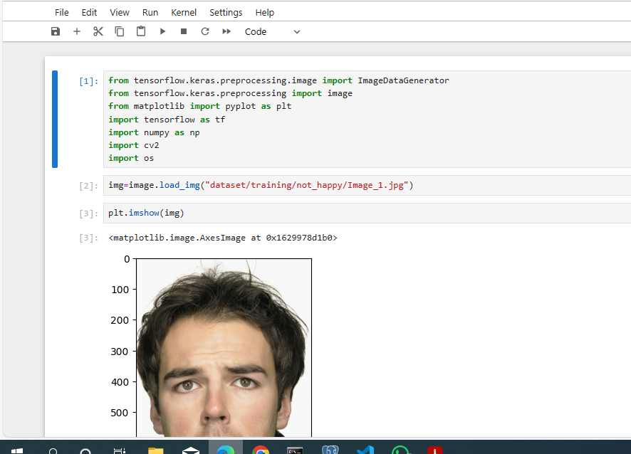

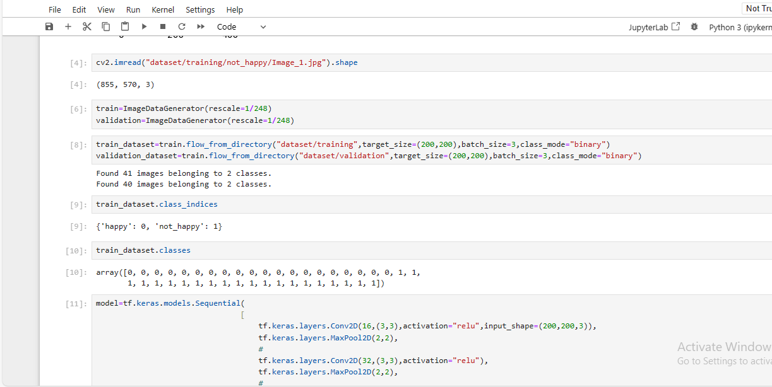

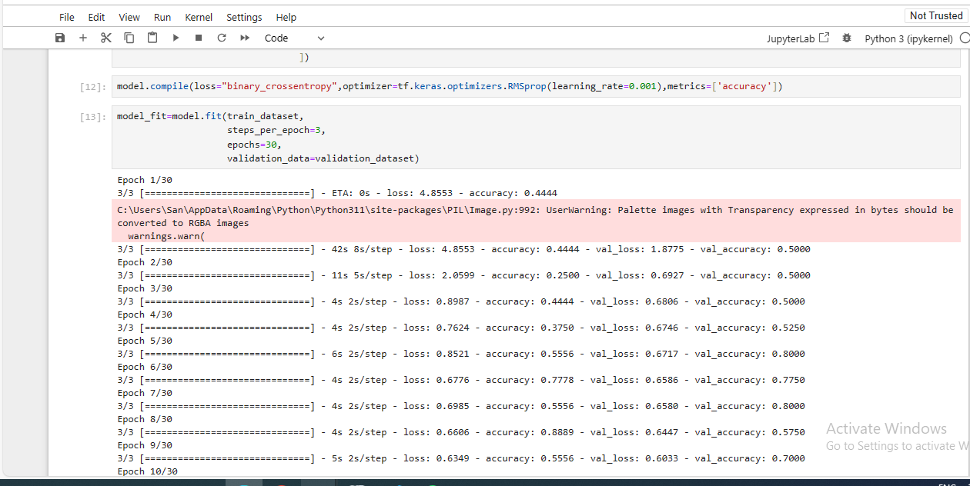

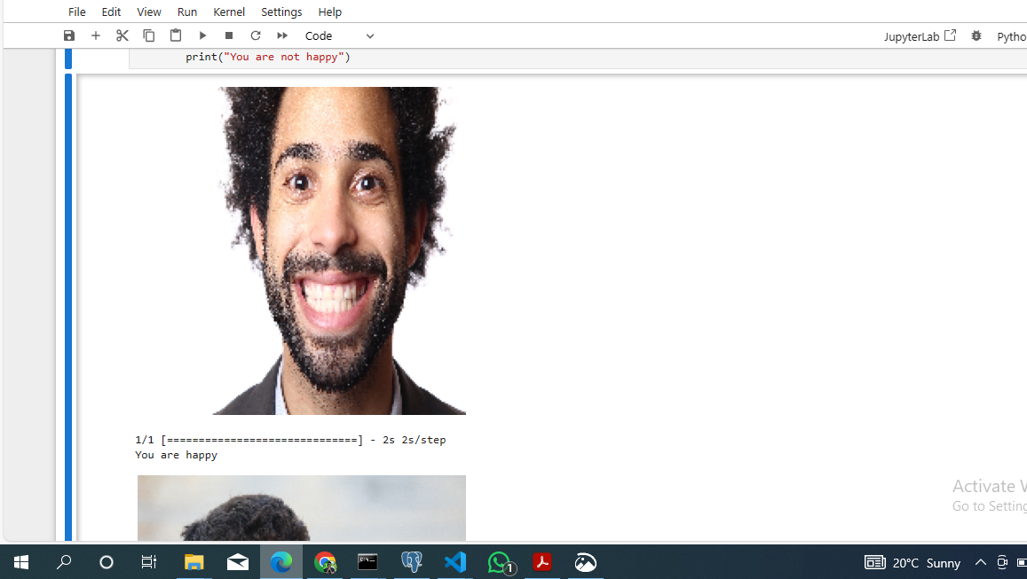

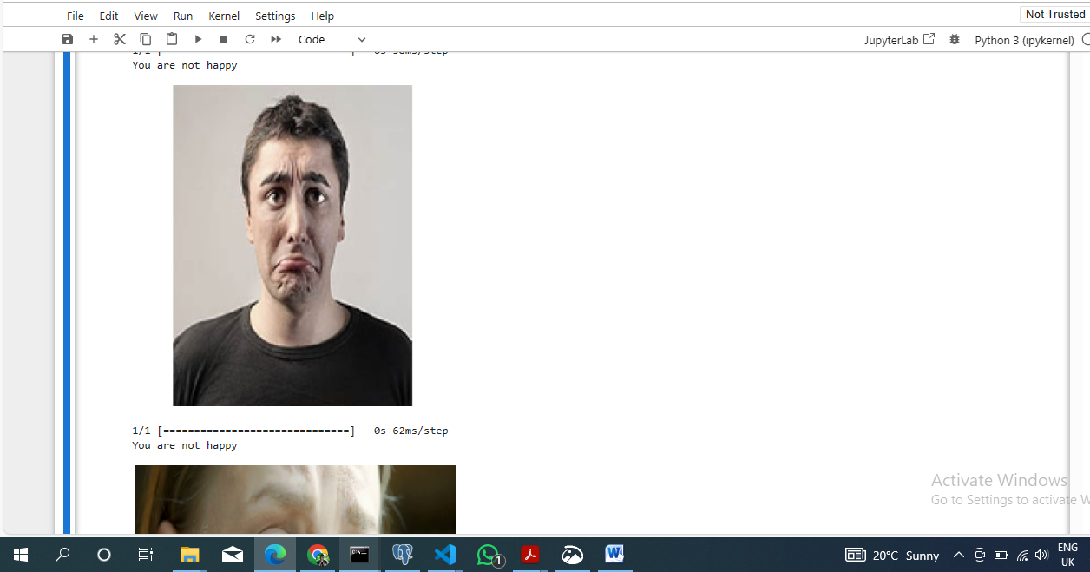

## Model Explanation

Due to depth-wise separable complicates, the MobileNetV2 architecture helps us capture and learn intricate details from our medical outfit set effectively (Almadan, 2023). The last, thick layers contribute to the prognostication, and here the model is adjusted for sensitivity using Adam optimizer together with categorical cross-entropy loss function. This violation supports the image-kind system that provides a strong foundation for confidential phases of training and evaluation practices.

## Illuminating translucency

The lawless gist of the MobileNetV2 was predicated on law patches and architectural justifications whereby the process is homogenized, inviting stakeholders to partake in knowledge deep passage.

# CHAPTER FOUR: MODEL TRAINING AND EVALUATION

## Dataset Splitting:

After consideration of passage model training, and evaluation the dataset was slated to a meticulous segmentation process that would allow it establish on firm basis for complete foundation. The training set is comprised of two prime margins, in which the testing set establishes a ground for assessing accumulated skills at specified models. The essence of this form parcelization lay in balancing the classification distribution, a conscious attempt to instill into the model something that is far from particular cases. The negative set, on the other hand, was constructed in order to add more structure into training and create confusion for looming overfitting’s spirit. This creation played a dual role: as a watchman in apprenticeship of anticipation necessarily follows the mold evolution, appeals to delay freezing every model into stiff scripts.

## Performance Analysis:

When the curtains of a stage rose for modeling application, many cried as an advocate left them MobileNetV2. ​By re-presenting it, the model gave a feeling of great elegance and grace similar to that typical in architecture’s grandeur.

The appraisal requirements gave rise to a broad story of what the model could do beyond sensitivity. The model's power in differentiating classes stood out more clearly with the help of confusion matrices, which resemble a painter's palette. Similar to a musical score, the ROC angles harmonized the model's sensitivity and specificity by making melodic music of its discriminating ability.

## Challenges Encountered:

Tunability underwent a gauntlet as the model training pilgrimage veered off schedule. Data augmentation and class weights facilitated the equalization of types that led to breaking tempests. The incorporated data enabled a polychromatic type to fit into the dataset; class weights adjusted with the model's literacy mechanism, making central groups important.

The optimization of hyperparameters became a classic ballroom dance, which implied graceful refinements improving the model's discriminating abilities. The literacy rate, batch size, and other hyperparameters vibrated notes in the symphony of optimization to make each adjustment more effective for categorizing capacity.

Challenges were not barriers but tests that constructed a more adaptable system. Iterative refinement is a dynamic between the challenges and promises of outcomes from it that drives toward an ocean-level performance. With the ability to understand medical object recognition, the model was fully developed – a symbol of this tension between challenges and successes in healthcare robotics. (Stefan et al., 2020)

# CHAPTER FIVE: PRACTICAL APPLICATION

## Integration into the Robot's System:

Now, the convergence of an independent, carefully trained model into a robot's system is a major turn that leads to some symphony in technology and reverberates throughout sanitarium territory. The model perfectly integrates into the robot's armature process and dramatically increases its perceptive abilities with power-strengthening object recognition. This symbiosis integration guarantees the robot can travel through a sanitarium room's sophisticated geography easily and freely.

As this robot pushes through its sapient integrated model in the clinical setting, it acts like eyes that keep looking and analyzing the field. This active real-time object recognition capability makes this robot become a subject of such a healthcare system. It could pick up a variety of medical instruments, such as stethoscopes and thermometers, with precision, elongating itself when necessary.

Synthesizing the model and robot in sanitarium topography guarantees continuous literacy and accommodation to health instruments and settings changeability.

## Use Cases and Benefits:

This is because of the wide range of medical treatments present in this technical marvel’s oil painting on capacities. The patient of a healthcare professional turns into an autonomous robot but not one that is free from limitations. In terms of identification clothing, an interesting operation script arises where a robot software assists the medical employees in identifying important devices. These not only hasten the important processes but also boost productivity in healthcare. Since power and demand are balanced, the robot’s ability to recognize objects serves as an effective guard dog in a world of force deployment. Such benefits are carried over to easy running in the hospitals with extensive efficiency and lowered mortality rate. Accordingly, the symphony of robotization and human activity emerges as a distinctive hallmark that characterizes this invention since it reflects an era when technology fuses with health care to facilitate quality patient service that offers better functionality.

# CONCLUDING REMARKS

## Summary of Findings:

Finally, the forced computer vision outcome successfully demolishes this problem of object recognition in a mental hospital space. Training the MobileNetV2 model specifically built on a carefully created dataset makes wider recognition sensitivity of medical clothing achievable.

## Reflection:

The reflection for this trip brings forward the inestimable assignments learned and is bandied below. The fundamental principle is the importance of the chosen dataset quality. The North Star points toward the detail and delicacy of object recognition in the dataset that's different, authentic, and applicable. The relationship between the dataset and model may be treated as a dance, where every action energies its beat. The process of iterative refinement demonstrated the dynamic developments in the structure models. Not walls but way monuments – hurdles including working with class imbalances and optimizing hyperactive parameters. We modify the model with surgical perfection and acclimatize it to understand this dataset, allowing us to facilitate its inflexibility and unmoving, which will help produce a revolution in healthcare robotics by reducing mortal intervention.

## Lessons Learned:

The aesthetic necessitated interdisciplinary collaboration between computer vision experts and healthcare facilities professionals. The use of deep literacy infrastructure and iterative model structure provides optimized computer vision procedures in the healthcare industry due to better technology knowledge by cases. The weave of invention and cooperation is the rattan that blends adaptability with progress.

# BIBLIOGRAPHY

Almadan, A., 2023. Deep learning models for mobile and wearable biometrics (Doctoral dissertation, Wichita State University).

Stefan, P., Traub, J., Hennersperger, C., Esposito, M. and Navab, N., 2020. Challenges in Computer Assisted Interventions: Challenges in design, development, evaluation, and clinical deployment of Computer Assisted Intervention solutions. In Handbook of Medical Image Computing and Computer Assisted Intervention (pp. 979-1012). Academic Press.

Tu, C.H., Lee, J.H., Chan, Y.M. and Chen, C.S., 2020, July. Pruning depthwise separable convolutions for mobile net compression. In 2020 International Joint Conference on Neural Networks (IJCNN) (pp. 1-8). IEEE.